Introduction
The COVID-19 epidemic produced some clarification of Southern California’s air quality problem. As overall vehicle miles dropped in spring 2020, nitrogen dioxide concentrations in the LA basin dropped significantly. This allowed researchers and policymakers to experiment with the relationship between vehicle emissions and ambient air quality. Venter et al. (2020) documented that traffic reductions in Southern California produced measurable NO2 improvements. Nevertheless, Kerr et al. (2021) showed
This question is imp
This study asks three questions. Do localized ZEV adoption rates correlate with NO2 and PM2.5 reductions across the sample of Southern California cities in 2021-2024? Second, how persistent are these reductions – does last year’s ZEV adoption predict this year’s air quality? Lastly, are these benefits equitably distributed across vulnerability quartiles defined by CalEnviroScreen?

Literature Review
COVID lockdowns produced a clear shift in ambient air quality as a result of vehicle activity. Saha et al. (2022) documented that NO2 and PM2.5 declined by more than 60% in many global megacities during these lockdowns. In Southern California, Parker et al. (2020) confirmed measurable improvements associated with traffic reductions. Kerr et al. (2021) showed that while the largest drops occurred in low-income and minority neighborhoods, racial NO2 disparities still happen because heavy-duty trucking persists. They conclude that targeting NOx from heavy-duty diesel is the most effective strategy for reducing these disparities nationwide, not passenger vehicle electrification.
Tessum et al (2019) explore the social dimension of my research question at a broader level level, finding that non-Hispanic white Americans experience about 17% less PM2.5 than is caused by their consumption, while Black and Hispanic Americans bear 56 to 63% excess exposure, respectively. PM2.5 exposures declined 50% from 2002 to 2015 for all groups, but pollution inequity remained persistently high.
Garcia et al. (2023) provided the first practical evidence in California linking zero-emission vehicle (ZEV) adoption to improved air quality and health. They found that for every increase of 20 ZEVs per 1,000 people, there was a 3.2% decrease in asthma-related emergency department visits. Although the association with NO2 was non-significant, the directional effect remained negative. Their adoption gap finding (lower-attainment zip codes grew ZEV fleets at ⅕ the rate of high-attainment zip codes) foreshows the equity question this study tests directly. Wang et al. (2026) document that the EV owner population has become more racially and geographically diverse between 2017 and 2022, but well-off urban households still account for roughly 64 percent of all EV owners.

Together, this literature generates three hypotheses:
- CalEnviroScreen burden should persistently predict air quality even after controlling for income and ZEV adoption.
- ZEV adoption at current penetration rates may not produce detectable ambient air quality improvements.
- The equity distribution of any ZEV effect likely follows the adoption gap, with higher-burden communities capturing fewer benefits.

Data and Methods (ask questions about it)
The study covers 20 Southern California cities with continuous EPA monitor coverage for both NO2 and PM2.5 across all four observation years (2021-2024), yielding a balanced panel of city-year observations. The balanced panel requirement dropped by ⅔ of candidate cities but ensures every regression observation is methodologically equivalent.
Air quality data come from the EPA AirData AQS annual summary files. PM2.5 uses the parameter code 88101, filtered to the Annual pollutant standard of Quarterly Means of Daily Means metric with >= 75% observation completeness. NO2 uses parameter code 42602 with the NO2 Annual 1971 standard. ZEV registration data comes from the California Energy Commission Vehicle Population dataset, aggregated from ZIP codes to cities using SimpleMaps. Census ACS 2020 5-Year estimates provide tract-level median household income, aggregated to the city level via HUD USPS ZIP-to-tract crosswalk weights. CalEnviroScreen 4.0 provides tract-level composite burden scores averaged to the city level by ZIP code matching. All control and moderation variables are fixed at 2020 pre-period values to avoid endogeneity.
Before running the regressions, variance inflation factor analysis on the raw variables confirms severe multicollinearity. ZEV adoption rate and CES score have VIF values of around 12.4 and 8.7 in the joint model, meaning the variables are so correlated with each other and the regression can’t separate each influence. The root cause is a shared wealth gradient or wealthier cities tend to have both higher ZEV adoption and lower environmental burden simultaneously. To resolve this, I apply the Frish-Waugh-Lovell theorem, which states that the coefficient on a variable in a multiple regression is equivalent to the coefficient you get if you first partial out the other regressors from both that variable and the outcome. In practice, I regressed ZEV_rate on income and fleet size, took the residuals, and used those residuals in the main model instead. The same applies to the CES_score. Afterwards, the correlation between the new ZEV_rate_resid and CES_score_resid is near 0 compared to the moderate negative correlation in the raw variables.

- Key Variables
  - Dependent
    - PM2.5 annual mean concentration (µg/m^3)
    - NO2 annual mean concentration (ppb)
  - Independent
    - ZEV_rate: share of ZEV vehicles in total registered fleet, per city-year
    - ZEV_rate_lag: prior year’s ZEV adoption rate (used in Model 3 and 4)
  - Moderating
    - CES_score: tract-level scores averaged to the city level, fixed at 2020 values
  - Control
    - Income_10k: median household income in $10,000 units (rescaled for readable coefficient)
- Empirical Strategy/Regression Models
  - Model 1 (Baseline): baseline socioeconomic gradient (how much does wealth alone explain)
  - Model 2 (Policy): Are ZEV and CES doing real explanatory work
    - β₂: expected to be negative (more ZEVs, less pollution)
    - β₃: expected to be positive (more burden, more pollution)
  - Model 3 (Persistence) : ZEV rate from the prior year predicts this year’s air quality
    - Sig negative β₂: ZEV adoption precedes cleaner air = persistence
      - 2021 obs drop out bc no prior year
  - Model 4 (Equity):
    - β₄ > 0: equity gap or smaller ZEV benefits in high-burden community
    - β₄ < 0: equity gain or larger ZEV benefits in high-burden communities
    - β₄ = 0: uniform effects across all vulnerability levels

Results (not finished)

Income: The income coefficient is close to zero and not statistically significant for either pollutant in the baseline model (R^2 = 0.061 for PM2.5; 0.014 for NO2). This likely does not indicate that income is unimportant for air quality, but that within this sample, the income range is too compressed relative to the state distribution, and this limits the variation needed to identify income effects.
CalEnviroScreen: CES_score_resid is positive and highly significant across each model and both pollutants. For PM2.5, the coefficient ranges from 0.2 to 0.22 μg/m^3 per unit, and for NO2, it’s 0.39 to 0.43 μg/m^3 per unit. This stability is the study’s strongest result: pre-existing environmental burden predicts current air quality even after controlling for income, fleet size, ZEV adoption, and year trends. All of this is consistent with Kerr et al. (2021) and Tessum et al. (2019)

ZEV Coefficient (M2, M3)
Interaction coefficient (M4)

Residual Analysis
- Residuals = actual air quality - model prediction given income, ZEV(t-1), CES.
- CES vs residual scatter plot

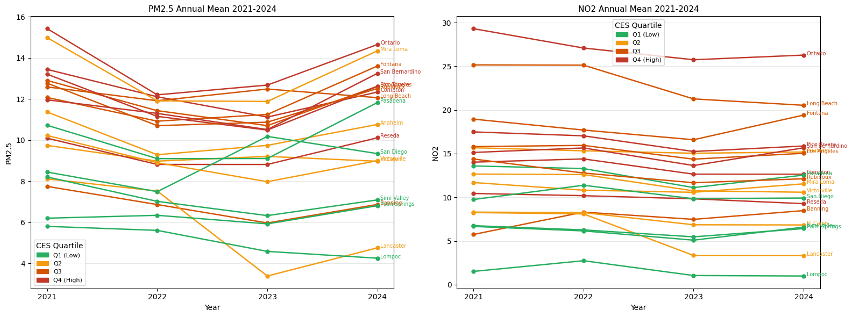
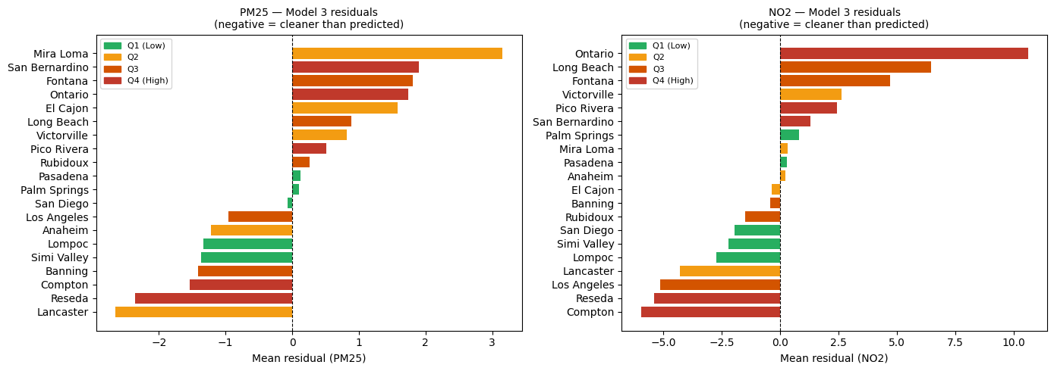
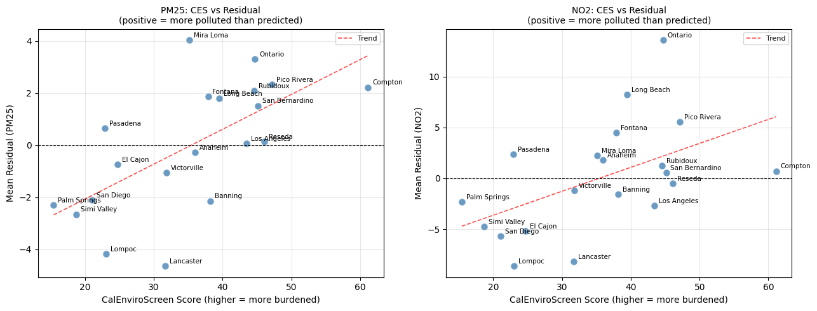
Model 3 residuals plotted against CES scores shows an upward-sloping trend for both pollutants. Ontario’s NO2 residuals exceed +10 ppb above prediction (largest deviation and consistent with its position). On the other hand, Lompoc and Lancaster are consistently cleaner than predicted (geographic isolation from freight corridors). This overall shows something unrelated to light-duty ZEV such as heavy fuel diesel as the primary mechanism sustaining the pollution in high-burden areas.

Regression Results

OLS Results - PM2.5
Variable | Model 1 | Model 2 | Model 3 | Model 4
income_10k | 0.046 | 0.046 | -0.015 | 0.052
ZEV_rate_resid | — | 47.34*** | — | —
ZEV_rate_lag_resid | — | — | 50.63* | 66.99**
CES_score_resid | — | 0.216*** | 0.204*** | 0.215***
ZEV * CES (interaction) | — | — | — | 1.49
N | 80 | 80 | 60 | 60
R^2 | 0.061 | 0.605 | 0.601 | 0.584
Adjusted R^2 | 0.011 | 0.572 | 0.556 | 0.537

*p<0.10 **p<0.05 ***p<0.01 .

Variable | Model 1 | Model 2 | Model 3 | Model 4
income_10k | -0.034 | -0.034 | -0.393 | -0.105
ZEV_rate_resid | — | 99.17* | — | —
ZEV_rate_lag_resid | — | — | 109.61* | 152.62*
CES_score_resid | — | 0.216*** | 0.204*** | 0.215***
ZEV * CES (interaction) | — | — | — | 1.49
N | 80 | 80 | 60 | 60
R^2 | 0.061 | 0.605 | 0.601 | 0.584
Adjusted R^2 | 0.011 | 0.572 | 0.556 | 0.537

*p<0.10 **p<0.05 ***p<0.01 .

Discussion

The positive ZEV coefficient shows that light-duty fleet electrification at current Southern California penetration rates (1-7% of registered vehicles) is not producing detectable air quality improvements. Garcia et al. (2023) found a nonsignificant but directionally negative NO2 association during 2013-2019 at even lower penetration, the switch to positive association in 2021-2024 may reflect that the post-COVID traffic rebound in high adoption cities is outpacing electrification gains. This indicates a threshold where low ZEV adoption cannot offset the emissions from the conventional fleet, requiring higher market penetration to achieve net NOx reductions.
The robustness of the CES coefficient is the most important policy-related finding. Environmental burden explains a good share of cross-city air quality variation independently of any concurrent policy variables. This follows with Tessum et al’s (2019) paper that pollution inequality is structural, and with Kerr et al.’s (2021) finding that even a near-elimination of passenger traffic failed to close racial NO2 disparities because heavy-duty trucking persists. The residual analysis in this study replicates that idea at the city level, where high-pollution cities like Ontario, Mira Loma, and Fontana are systematically more polluted than the ZEV adoption and income would predict.
The non-significant equity interaction means there is no detectable differential in how ZEV adoption affects air quality across high vs low burden areas. This means that high-burden areas are not benefiting more from the ZEV adoption, but they are also not benefiting less. The structural inequity indicated by the CES coefficient is constant regardless of local ZEV penetration, and likely will continue to be unless policy addresses the freight and industrial sources that light-duty electrification does not reach.

Conclusion

This study estimated the relationship between localized ZEV adoption and air quality persistence across 20 Southern California cities from 2021 to 2024, and there were three main results. CalEnviroScreen burden is the most dominant predictor of both NO2 and PM2.5, and this is robust across all model specifications and consistent with the structural inequality literature. Second, ZEV adoption at current penetration rates is not associated with air quality improvement. The lagged persistence test confirms that no delayed benefit is accumulating over the one-year horizon studied. Lastly, there is no detectable equity differential in the ZEV air quality effect.
These results support Kerr et al.'s (2021) conclusion that strategies targeting heavy-duty diesel emissions are likely more effective at reducing air pollution than passenger vehicle electrification alone. Given evidence of increased ZEV adoption in high-income cities, are also consistent with Wang et al.'s (2026) concern that the adoption rate means that even if ZEVs eventually produce ambient air benefits, these benefits will accumulate in communities that need them the least.
I believe that extending the panel of the research through 2025-2026, incorporating Rule 2305 compliance data to warehouse-sector electrification effects, and deploying a tract-level analysis to capture intra-city variation in ZEV adoption and exposure.
Garcia, Erika et al. “California's early transition to electric vehicles: Observed health and air quality co-benefits.” The Science of the total environment vol. 867 (2023): 161761. doi:10.1016/j.scitotenv.2023.161761

Kerr, Gaige Hunter et al. “COVID-19 pandemic reveals persistent disparities in nitrogen dioxide pollution.” Proceedings of the National Academy of Sciences of the United States of America vol. 118,30 (2021): e2022409118. doi:10.1073/pnas.2022409118

Parker, H. A., Hasheminassab, S., Crounse, J. D., Roehl, C. M., & Wennberg, P. O. (2020). Impacts of Traffic Reductions Associated With COVID‐19 on Southern California Air Quality. Geophysical Research Letters, 47(23). https://doi.org/10.1029/2020gl090164

Saha, Lala et al. “The impact of the COVID-19 lockdown on global air quality: A review.” Environmental sustainability (Singapore) vol. 5,1 (2022): 5-23. doi:10.1007/s42398-021-00213-6

C.W. Tessum, J.S. Apte, A.L. Goodkind, N.Z. Muller, K.A. Mullins, D.A. Paolella, S. Polasky, N.P. Springer, S.K. Thakrar, J.D. Marshall, & J.D. Hill, Inequity in consumption of goods and services adds to racial–ethnic disparities in air pollution exposure, Proc. Natl. Acad. Sci. U.S.A. 116 (13) 6001-6006, https://doi.org/10.1073/pnas.1818859116 (2019).

Wang, J., Harper, C. D., & Hendrickson, C. (2026). Changing US electric vehicle owner socioeconomic characteristics. Transportation Research Interdisciplinary Perspectives, 35, 101788. https://doi.org/10.1016/j.trip.2025.101788

California Air Resources Board. (2023). Advanced Clean Cars II Regulation. Sacramento, CA: CARB.

California Energy Commission. (2025). Zero-Emission Vehicle and Infrastructure Statistics Data. Sacramento, CA: CEC.

Office of Environmental Health Hazard Assessment. (2021). CalEnviroScreen 4.0. Sacramento, CA: OEHHA.

U.S. Census Bureau. (2021). American Community Survey 5-Year Estimates, 2016–2020. Washington, DC.

U.S. Department of Housing and Urban Development. (2020). USPS ZIP Code Crosswalk Files, Q4 2020. Washington, DC.

